Group members
- 1 omkar wani :20251502020
- 2 kanhaiya:20251502013
- 3 pranav bahekar :20251502006
- 4 jitendra:20251502012
- 5 sandeep:20251502029

BUS RESERVATION SYSTEM
About the Project
Our project is a Bus Reservation System. We chose this topic because booking a bus ticket is something many people do, especially when travelling between cities. In a traditional booking process, passengers may have to visit a booking counter, check seat availability manually, and wait in a queue.
The main idea of our system is to make this process easier. A passenger should be able to search for a bus, check the available seats, choose a seat, enter their details, pay for the ticket and receive a booking confirmation.
The system also gives bus operators a way to manage buses, routes, schedules and bookings.
What the System Can Do
- Search for buses
- Check bus details
- Check available seats
- Select a seat
- Book a ticket
- Calculate the ticket price
- Make an online payment
- View existing bookings
- Cancel a booking
- Manage buses
- Manage routes
- Manage schedules
- Update seat status
- Send booking notifications
Actors
The main actors in our system are:
- · Passenger
- · Bus Operator
- · Administrator
- · Payment Gateway
- · Notification Service
- · System Scheduler

UML Concepts Covered

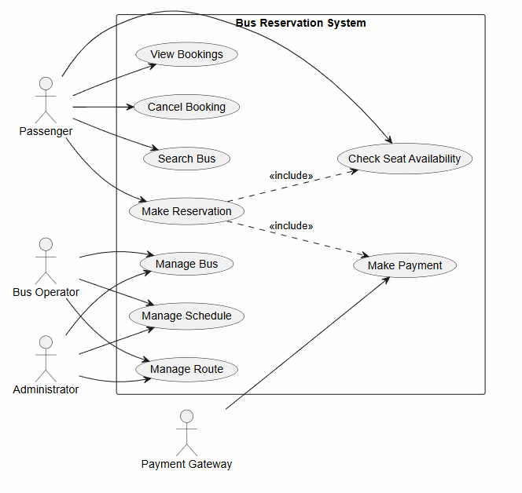

Project Domain
Bus Reservation System
Purpose
The purpose of this project is to understand how a real-world bus booking process can be represented using UML and object-oriented concepts.

Problem Statement : Bus Reservation System
Booking a bus ticket can sometimes be a tiring process. If a person wants to travel to another city, they may have to visit a booking counter or depend on someone else to check which buses and seats are available. During weekends, holidays and festival seasons, the counters can become crowded and finding a suitable seat can take even more time.
We want to develop a Bus Reservation System that makes this process simpler. A passenger should be able to enter their starting point, destination and travel date and see the buses available for that journey. The system will show useful information such as the bus name, departure time, arrival time, ticket price and available seats.
After finding a suitable bus, the passenger can select an available seat and enter their details. The system will calculate the total ticket amount and allow the passenger to pay online. After successful payment, the booking will be confirmed, and a booking reference number will be given to the passenger.
Sometimes a passenger may need to cancel a ticket. The system should allow cancellation when the booking meets the cancellation rules. When a booking is cancelled, the seat should become available again. If the passenger is eligible for a refund, the system should also start the refund process.
The bus operator will use the system to manage buses, routes and schedules. They can also check the reservations made for their buses. An administrator will handle important information such as adding buses and managing routes.
The system can use an external payment gateway to process online payments. A notification service can be used to send booking confirmations and cancellation messages to passengers.
The main goal of our Bus Reservation System is to make booking a bus ticket quicker and more convenient. At the same time, it should reduce manual work, keep booking information organized and help avoid problems such as two passengers getting the same seat.

Use Case Specifications

1. Make Reservation

Primary Actor
Passenger

Stakeholders
· Passenger: Wants to book a bus and get a suitable seat.
· Bus Operator: Wants correct passenger and booking information.
· Administrator: Wants the booking records to be accurate.
· Payment Gateway: Needs to process the passenger's payment.

Preconditions
· The passenger has searched for a bus.
· The selected bus is available.
· The selected trip has at least one available seat.
· The passenger has selected a travel date.

Postconditions
If the booking is successful:
· A reservation is created.
· The selected seat is reserved.
· Payment is completed.
· A booking reference number is generated.
· The passenger receives a confirmation.
If the booking fails, the reservation is not confirmed.

Trigger
The passenger selects a bus and clicks Book Ticket.

Main Flow
1. Passenger enters the source, destination and travel date.
2. System shows the available buses.
3. Passenger chooses a bus.
4. System shows the bus details and available seats.
5. Passenger selects a seat.
6. System checks whether the selected seat is still available.
7. System temporarily holds the seat.
8. Passenger enters their details.
9. System calculates the ticket fare.
10. Passenger confirms the booking.
11. System sends the payment request to the Payment Gateway.
12. Payment Gateway processes the payment.
13. System creates the reservation.
14. System marks the selected seat as reserved.
15. System generates a booking reference number.
16. System sends a confirmation notification.
17. System shows the booking details to the passenger.

Flow 1 : Seat Is No Longer Available
Guard condition: [seat unavailable]
1. Passenger selects a seat.
2. System checks the seat status.
3. System finds that another passenger has already reserved the seat.
4. System tells the passenger that the seat is no longer available.
5. Passenger selects another seat.
6. System continues with the booking.

Flow 2 : Payment Fails
1. Payment Gateway rejects the payment.
2. System displays a payment failure message.
3. Booking is not confirmed.
4. System releases the temporarily held seat.
5. Passenger can try the payment again or cancel the booking.

2. Cancel Booking

Primary Actor
Passenger

Stakeholders
· Passenger: Wants to cancel the ticket and get a refund if applicable.
· Bus Operator: Wants the cancelled seat to become available again.
· Administrator: Wants the booking records to remain accurate.
· Payment Gateway: Processes the refund when required.

Preconditions
· Passenger has an existing booking.
· Booking has not already been cancelled.
· The booking is eligible for cancellation.

Postconditions
If successful:
· Booking status changes to Cancelled.
· The seat becomes available.
· Refund is started if applicable.
· Passenger receives a cancellation confirmation.

Trigger
Passenger selects Cancel Booking.

Main Flow
1. Passenger logs into the system.
2. Passenger opens their bookings.
3. System displays the passenger's bookings.
4. Passenger selects the booking they want to cancel.
5. Passenger clicks Cancel Booking.
6. System checks whether cancellation is allowed.
7. System shows the refund information.
8. Passenger confirms the cancellation.
9. System changes the booking status to Cancelled.
10. System makes the seat available again.
11. System starts the refund process if required.
12. System sends a cancellation notification.
13. System displays the cancellation confirmation.

Alternate Flow 1 — Cancellation Not Allowed
1. Passenger selects a booking to cancel.
2. System checks the cancellation rules.
3. System finds that the booking cannot be cancelled.
4. System informs the passenger.
5. Booking remains active.

Alternate Flow 2 — Refund Is Delayed
1. System cancels the booking successfully.
2. System sends a refund request.
3. Payment Gateway reports a problem with the refund.
4. System marks the refund as pending.
5. Passenger is informed that the refund will be processed later.

3. Manage Schedule

Primary Actor
Bus Operator

Stakeholders
· Bus Operator: Wants the bus schedules to be correct.
· Administrator: Wants accurate route and schedule information.
· Passenger: Wants to see the correct departure and arrival times.

Preconditions
· Bus Operator is logged in.
· Operator has permission to manage schedules.
· Bus and route information already exists.

Postconditions
If successful:
· New or updated schedule is saved.
· Passengers can see the updated schedule.
· The schedule is connected to the correct bus and route.

Trigger
Bus Operator chooses Manage Schedule.

Main Flow

1. Bus Operator logs into the system.
2. Operator opens the schedule section.
3. System displays the existing schedules.
4. Operator chooses to add or update a schedule.
5. Operator selects a bus.
6. Operator selects a route.
7. Operator enters the departure and arrival times.
8. System checks the entered information.
9. System checks whether the bus is already assigned to another trip at that time.
10. System saves the schedule.
11. System updates the trip information.
12. System displays a success message.

Alternate Flow 1 — Bus Is Already Scheduled
1. Operator enters a new schedule.
2. System checks the existing schedules.
3. System finds that the same bus is already assigned to another trip at that time.
4. System displays a schedule conflict message.
5. Operator chooses another bus or time.

Alternate Flow 2 — Route Is Invalid
1. Operator selects a route.
2. System checks the route.
3. System finds that the route is inactive or invalid.
4. System displays an error message.
5. Operator selects another valid route.

Question 1 — Noun–Verb Analysis

Bus Reservation System

1. Raw Candidate Noun List2. Four Filters Used

No. | Candidate Noun
1 | Passenger
2 | Bus
3 | Bus Operator
4 | Administrator
5 | Payment Gateway
6 | Notification Service
7 | Reservation
8 | Booking
9 | Ticket
10 | Seat
11 | Route
12 | Schedule
13 | Trip
14 | Payment
15 | Refund
16 | Cancellation

Filter 1 — Duplicate / Synonym
- Booking → eliminated because it represents the same concept as Reservation.

Filter 2 — Attribute
The following candidates are properties of other classes and are therefore eliminated as separate classes:

- Source
- Destination
- Departure Time
- Arrival Time
- Travel Date
- Fare
- Booking Reference
- Seat Status

Filter 3 — Technical / Implementation Concept
The following are not core domain classes:

- System
- Login
- Error Message
- Success Message

Filter 4 — External / Out-of-Domain Concept
The following are external actors/services rather than core domain classes:

- Payment Gateway
- Notification Service
- System Scheduler

3. Surviving Classes
After applying the four filters, the following classes survive:

- Passenger
- Bus Operator
- Bus
- Route
- Schedule
- Trip
- Seat
- Reservation
- Payment
- Refund

4. Discarded Candidates and Filter
Candidate | Result | Filter | Reason
Administrator | Discarded | Filter 4 | Actor/administrative role, not required as a core domain class
Payment Gateway | Discarded | Filter 4 | External system
Notification Service | Discarded | Filter 4 | External service
Booking | Discarded | Filter 1 | Synonym/duplicate of Reservation
Ticket | Discarded | Filter 1 | Treated as part of the Reservation/booking concept
Source | Discarded | Filter 2 | Attribute of Route
Destination | Discarded | Filter 2 | Attribute of Route
Departure Time | Discarded | Filter 2 | Attribute of Schedule
Arrival Time | Discarded | Filter 2 | Attribute of Schedule
Travel Date | Discarded | Filter 2 | Attribute of Trip
Fare | Discarded | Filter 2 | Attribute of Reservation
Booking Reference | Discarded | Filter 2 | Attribute of Reservation
Seat Status | Discarded | Filter 2 | Attribute of Seat
Cancellation | Discarded | Filter 2 | Behaviour/operation of Reservation
System | Discarded | Filter 3 | Technical/system concept
Login | Discarded | Filter 3 | System functionality, not a domain class
Error Message | Discarded | Filter 3 | UI/system message
Success Message | Discarded | Filter 3 | UI/system message

5. Final Answer
Surviving classes:

Passenger, Bus Operator, Bus, Route, Schedule, Trip, Seat, Reservation, Payment, Refund.

Question 2 — CRC Cards

Bus Reservation System
CRC stands for Class – Responsibilities – Collaborators.

The following CRC cards are prepared for the 10 surviving classes identified during noun–verb analysis.

CRC Card 1 — Passenger
Class Name: Passenger

Responsibilities:

- Search for available buses
- Select a seat
- Make a reservation
- View existing bookings
- Cancel a booking

Collaborators:

- Reservation
- Trip
- Seat

CRC Card 2 — Bus Operator
Class Name: Bus Operator

Responsibilities:

- Manage buses
- Manage routes
- Create and update schedules
- Check schedule conflicts

Collaborators:

- Bus
- Route
- Schedule

CRC Card 3 — Bus
Class Name: Bus

Responsibilities:

- Store bus information
- Provide bus details
- Provide available seat information
- Maintain its seats

Collaborators:

- Seat
- Trip
- Schedule

CRC Card 4 — Route
Class Name: Route

Responsibilities:

- Store source and destination
- Validate route information
- Provide route details

Collaborators:

- Schedule
- Trip

CRC Card 5 — Schedule
Class Name: Schedule

Responsibilities:

- Create a bus schedule
- Update a bus schedule
- Store departure and arrival times
- Check schedule conflicts

Collaborators:

- Bus Operator
- Bus
- Route
- Trip

CRC Card 6 — Trip
Class Name: Trip

Responsibilities:

- Store travel date
- Provide trip details
- Provide available seat information
- Connect a bus with a particular journey

Collaborators:

- Bus
- Route
- Schedule
- Seat
- Reservation

CRC Card 7 — Seat
Class Name: Seat

Responsibilities:

- Check seat availability
- Hold a seat
- Reserve a seat
- Release a seat after cancellation or failed payment

Collaborators:

- Bus
- Trip
- Reservation

CRC Card 8 — Reservation
Class Name: Reservation

Responsibilities:

- Create a reservation
- Calculate ticket fare
- Confirm a booking
- Cancel a booking
- Generate a booking reference

Collaborators:

- Passenger
- Trip
- Seat
- Payment
- Refund

CRC Card 9 — Payment
Class Name: Payment

Responsibilities:

- Process payment
- Store payment information
- Check payment status

Collaborators:

- Reservation
- Payment Gateway

CRC Card 10 — Refund
Class Name: Refund

Responsibilities:

- Calculate refund amount
- Initiate refund
- Process refund
- Store refund status

Collaborators:

- Reservation
- Payment Gateway

Summary Table
Class | Main Responsibilities | Collaborators
Passenger | Search, reserve, view and cancel bookings | Reservation, Trip, Seat
Bus Operator | Manage buses, routes and schedules | Bus, Route, Schedule
Bus | Store bus details and seat information | Seat, Trip, Schedule
Route | Store and validate route | Schedule, Trip
Schedule | Create/update schedules and check conflicts | Bus Operator, Bus, Route, Trip
Trip | Manage journey details and seats | Bus, Route, Schedule, Seat, Reservation
Seat | Check, hold, reserve and release seats | Bus, Trip, Reservation
Reservation | Create, confirm, calculate fare and cancel booking | Passenger, Trip, Seat, Payment, Refund
Payment | Process and track payment | Reservation, Payment Gateway
Refund | Calculate and process refund | Reservation, Payment Gateway

QUESTION 3:Draw a domain class diagram:
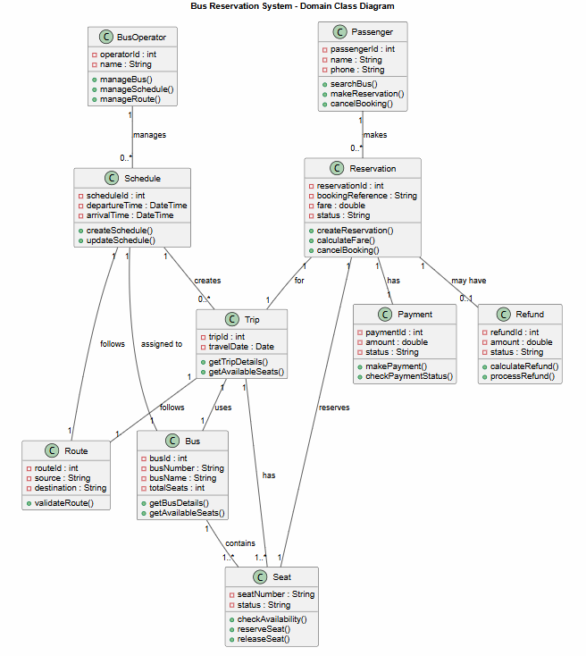

QUESTION 4: object diagram
